# **Lane Detection System Using MATLAB**

**Muhammad Hamza Aslam**

Department of Computer Science

University y of Management of Technology

***Abstract*-i** n this paper I present a video based lane detection system which take input video file and after all processing it detect lane and show on output video file to maximize the output of this system I use cheap hardware and software to full fill all users. This proposed system is designed specially for low or cheap cost camera and then it processing depends upon your laptop or any other device where you run your software. So today we face many difficulties in road while driving also we see many accidents on road this system detect lines and also you make route according to it. This system is able to detect the lines on highways where minimum of 3 lanes in a road. This system specially design for highways or long roads where speed of vehicle are high. Our system work properly on every road but have some issue on some road where road quality low or paint of road is differ. Although accuracy of our system is 90% and we apply our algorithm on multiple videos and get good result we take input files from git hub image processing video bank.

***Index Terms***- Region of interest (ROI),Matrix laboratory (MATLAB), Extrapolation of lines(EOL)

1. Introduction

We see so many accident in daily life to avoid this we have to make system which detect roads vehicle and curves.also the traffic density is increases day by day and the speed of driving play an important role to avoid accident on road.so to make system which avoid all this first we have to detect the road and lane of road which is our main goal of this paper.the main objective of this system is to detect lane on a road and tell the direction where to move which avoid road accident which happen when people usually sleep or the ignore focus on road.

To detect lane on road first we have to knowledge about the road how road are made and how they make lane on roads.so almost of 3.5 meter which means 350 cm width each lane contains so if we consider 3 lane highways we have 1300 cm total width. But our algorithm work on first lane most probably because its idle to drive in first lane so rather then 350cm we see yellow line but on left side of yellow line we see some extra width which we have to ignore its almost about 550cm because our car work in a lane not in extra space.

After all this knowledge now you should know about MATLAB built in function which we use in my project like edge, imgaussfilt ,video writer, imread, etc. Also you should have knowledge about mathematics because most of the work is base on calculation like cross product, slope calculation,theta,sin,cos etc.Then main part some concept like edge detection, lane detection,RGB into Grey scale,extrapolation of line, region of interest which we use further and I also explain bellow.

1. literature review

Most of the accident are caused by lack of concentration and avoid safety measurement.many people not maintain safe distance from other car and not pay attention when they switch lane or they turn their vehicle which leads to major accidents on roads.this project is about to detect lane of the road also if the curve is in road they show direction left right straight accordingly.this system measure the slope of the picture pixel frame which we get from video reader build function and process it which we discuss bellow and show the results in form of output video file in .avi format.

For safety of our user vehicle safety play an important role and also to avoid crashes and clash between vehicle we have to make a system which take responsibly of both these thing and our system is the first step toward safety system.

Table1: Literature Table

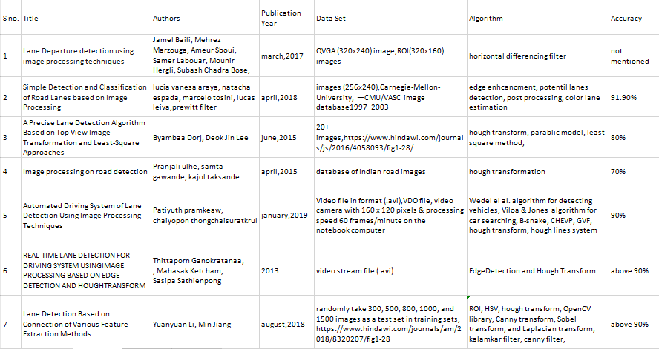

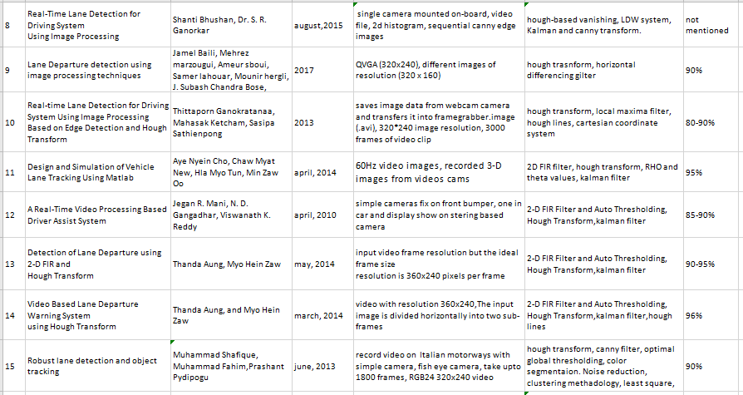

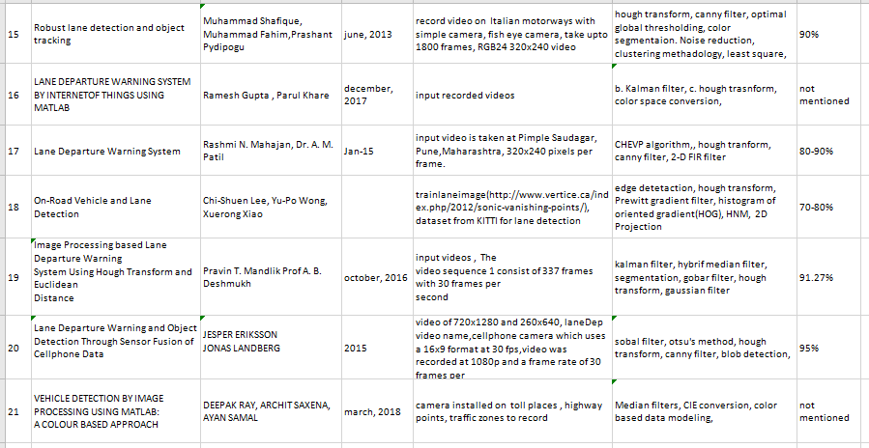

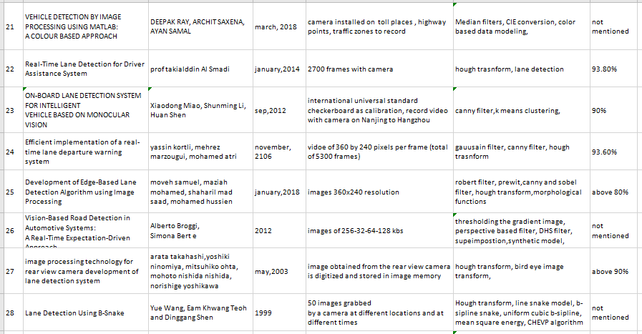

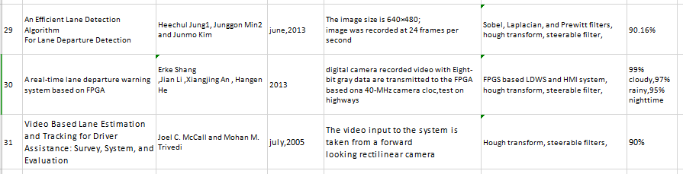

1. methadology

Our main objective to detect lane[3] on a road which help our user in improving his driving and later on we enhance our system for self driving assistant system when we practically apply our system in cars where system take real time video input from camera deploy on car front and processing show on their screen in real time which decrease or low accidents and also save people time who don’t know driving or they are not be able to drive I use following methodology for my system which I use to deploy my system

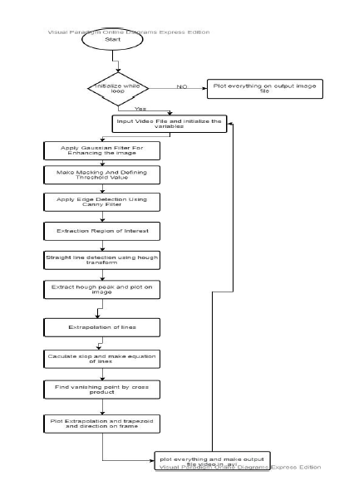

1. **Take Input File**

Most important part is to input the video file by using built in function of MATLAB video reader and also create some variable [6]and while loop for processing in each frame of video file which we use further.we take input file from GITHUB if you want video file kindly contact on my email.see the below image fig 1

VideoFile = VideoReader('project.mp4');

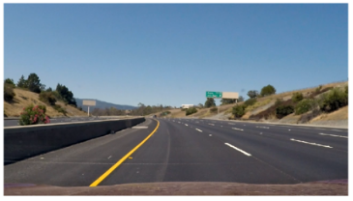

Fig 1

1. **Initialize variable and create output file**

Initialize the variables which we use and for user we create a output video file in .avi format where my all frames where my system do processing save in a file using built in function in MATLAB video writer

Output-Video=VideoWriter('result-video');

Output-Video.FrameRate= 25;

1. **Enhance image**

Enhance image using Gaussian filter which is best among all other options it sharrpen the image by sharpening the edge and all detail of image .after filtering image look like fig 2

frameOfImage = imgaussfilt3(frame);

figure('Name','Gaussian Filtered Image'), imshow(frameOfImage);

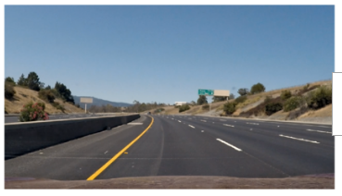

Fig 2

1. **Masking or define threshold value**

As I discuss above we have two line yellow and white [7]so I have to write values for both color and also involve hue and saturation and also decide max range because we only need yellow and white line of road with some ratio as shown in bellow image how I separate yellow and white line for processing see the fig 3 and 4

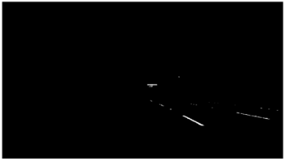

Fig 3

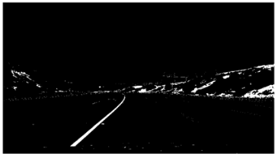

Fig 4

1. **Edge Detection**

After defining all the value of for hue saturation and also maximum value for image frame now the main part come of edge detection is there any edge or not I use canny filter[9][11] For both yellow and white lane. So we have two color lane as we all know

bw = edge(I,'Canny',0.5);

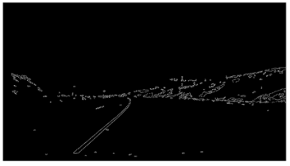

Fig 5

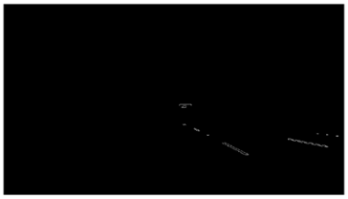

Fig 6

1. **Extraction of Region of interest**

Region of interest we defined as the part of image you want so in our system we want lane which is between yellow and white line so I use roipoly function which is built in MATLAB to extract region of interest for both yellow and white color see fig 7 8

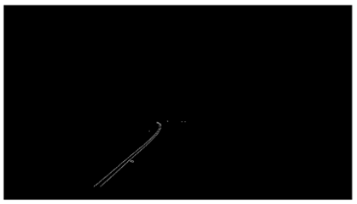

Fig 7

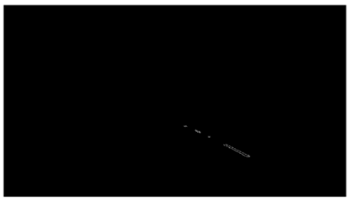

Fig 8

1. **Hough transform**

For straight line detection I use hough transform [1]which is built in function of MATLAB I use

hough peak for hough transform frame and use hough for theta values which we further use

for both lane yellow and white.I use built in function

hough

houghlines

1. **Extrapolation of Lines**

We need start and end point because we don’t process on whole road we divide video file into frames 25 per second and later on we use just small part where we do processing.So after hough peak[2][6] we plot on left and right side and after that we calculate slope and make right and left equation of line which I extrapolate , see the fig 9

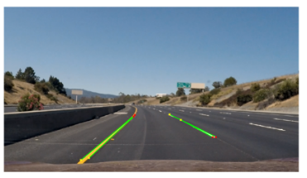

Fig 9

1. **Turn Prediction**

Now main part after all processing we have to predict so I use built in function name cross to write left right point also consider all value which we calculate like theta rho and also value of saturation hue etc.Here we calculate slope for better results

slope = (y-2-y-1)/(x-2-x-1);

Where x1 x2 y1 y2 are the dot product of xy with

* x-1 = xy(1,1);
* y-1 = xy(1,2);
* x-2 = xy(2,1);
* y-2 = xy(2,2);

If we get negative slope then our left prediction code is execute otherwise right prediction code is running

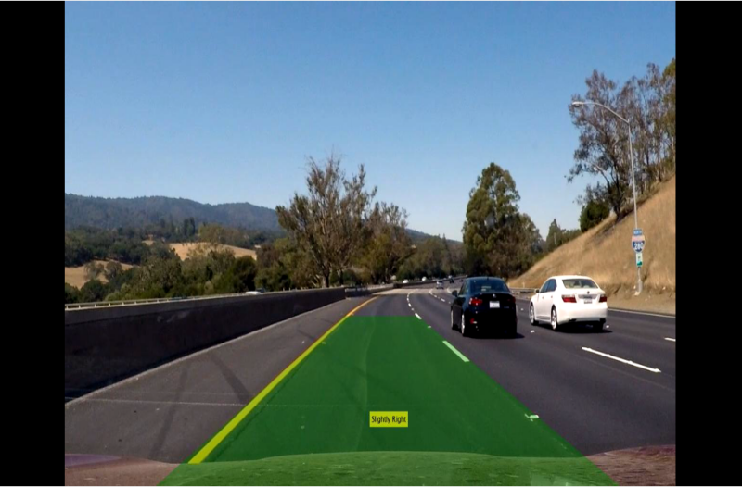

1. result and analysis

So as you see after the all processing we can say that our algorithm is properly working it also detect the lane properly.It only work on highways as I discuses in introduction our proposed system is only for lane detection not for proper driving assistant system we further working on it also the one more thing I add is detect lane on first because our algorithm made for first lane but it also work on second lane of road just by few changes.

Although it work properly but it not detect lane on highways where tree or more traffic is here but we are working on it as you see in above image they properly show the direction where to turn the car. Its accuracy rate is 90% , it work properly on every input video where we just want to detect lane and show on screen.

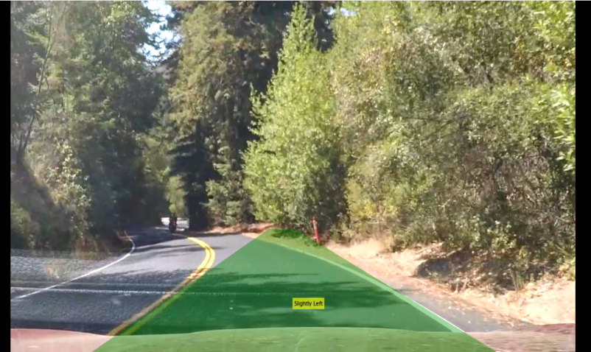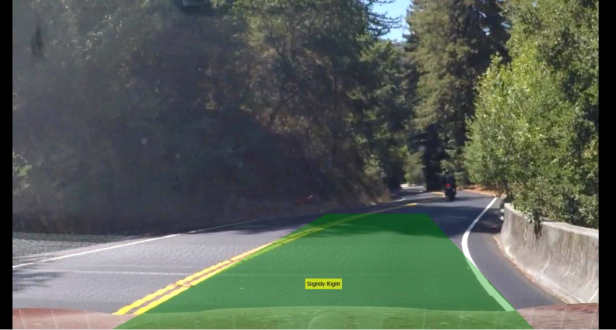

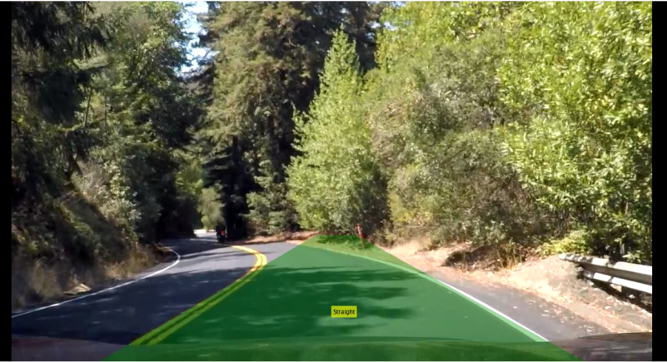

1. Future Work

Now my system detect lane on roads properly but work is not done yet now I have to detect curves,obstacle,tree and all other types of things which may come in front of user car then later on our main goal is to develop the system which detect vehicle on road and tell user a alarm message that our future goal.

1. conclusion

This system is made just for detect lane on the road not for proper driver assistant system also they don’t detect curved, obstacle, divider, footpath they re not included in our system to detect but we further process on it and also working to improve our system for future.although accuracy is 90% on highways road and for code and data set email me.

References

1. https://medium.com/@esmat.anis/robust-extrapolation-of-lines-in-video-using-linear-hough-transform-edd39d642ddf
2. https://towardsdatascience.com/finding-lane-lines-simple-pipeline-for-lane-detection-d02b62e7572b
3. https://pdfs.semanticscholar.org/4ac5/d51a93735a7d36224e985265737eda0413e3.pdf
4. https://www.researchgate.net/publication/316450089_Lane_Departure_detection_using_image_processing_techniques
5. https://www.researchgate.net/publication/256097916_A_Real-Time_Video_Processing_Based_Driver_Assist_System
6. [https://www.mathworks.com/help///gpucoder/examples/lane-detection-using-houghlines.html](https://www.mathworks.com/help/gpucoder/examples/lane-detection-using-houghlines.html)
7. Simple Detection and Classification of Road Lanes based on Image Processing
8. Image processing on road detection [Pranjali ulhe, samta gawande, kajol taksande]
9. Lane Departure detection using image processing techniques[Jamel Baili, Mehrez Marzouga, Ameur Sboui, Samer Labouar]
10. Lane Departure detection using image processing techniques [Jamel Baili, Mehrez marzougui, Ameur sboui, Samer lahoua
11. Cong Hoang Quach, Van Lien Tran, Duy Hung Nguyen, Viet Thang Nguyen, Minh Trien Pham, Manh Duong Phung "Real- time Lane Marker Detection Using Template Matching with RGB-D Camera", 2018 2nd International Conference on Recent Advances in Signal Processing, Telecommunications Computing (SigTelCom).
12. Lioris,Annie Bracquemond, Gildas Thiolon, Laurent Bonic, "Lane Change detection algorithm on real world driving for arbitrary road infrasructures", 2nd IEEE International Conference on Computer Software Applications,2018.
13. K.Mirunalini, Dr.(Mrs).Vasantha Kalyani David, "Techniques for Detection of Lanes on RoadsA Review", International Journal of Pure and Applied Mathematics Volume 118 No. 18 2018, 2835-284.
14. Zhong-xun Wang* and Wenqi Wang, "The research on edge detection algorithm of lane", EURASIP Journal on Image and Video Processing.
15. Mingfa Li , Yuanyuan Li , and Min Jiang, "Lane Detection Based on Connection of Various Feature Extraction Methods", Hindawi, Advances in Multimedia, Volume 2018.
16. Gianni Cario, Alessandro Casavola, Marco Lupia, "Lane Detection and Tracking Problems in Lane Departure Warning System", 2017

Authors

**First Author** – Muhammad Hamza Aslam, bachelor in computer science, university of management and technology ,hamzaaslam380@gmail.com